These exercises will help you perform better on the National Tests.
Part 1: Listening Comprehension
Watch the video and do the exercise below.
Donald Trump vs Average American - Who Is Better - Celebrity / Presidential Comparison

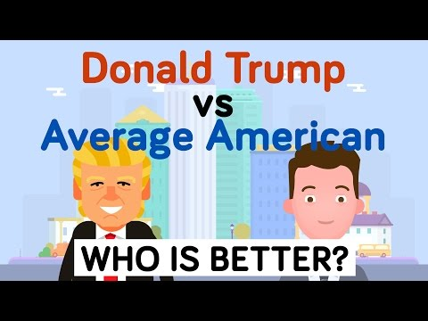

Difficult words with definitions:
 | Difficult word/phrase | Easier replacement | Swedish translation
1 | controversial | argument-causing
2 | campaign | (series of actions to reach a goal)
3 | vowed | promised
4 | purported | claimed
5 | versus | against/compared to/or
6 | deviate | move away
7 | difficult to | hard to
8 | financial | (money-related)
9 | estimated | guessed
10 | adjusted | (changed to make better/changed to fit new conditions)
11 | a mere | a little
12 | exact | precise
13 | inherited | received
14 | approximately | about
15 | exotic | fancy
16 | phantom | ghost
17 | not to mention | and
18 | charitable | helpful
19 | annual | once-a-year
20 | extramarital | outside-of-marriage
21 | repeatedly | over and over again
22 | recently | (not very long ago)

Now write the correct word in the blanks. Use the words above!
Donald Trump was elected the 45th President of the United States after what was surely one of the most _________________ election cycles in United States history. Trump based much of his _________________ around the idea that he is sick of how the "average American" is being treated, and _________________ to change it. But just who is this “average American” and how much does Donald Trump have in commonwith him? Let’s see in this comparison of Donald Trump vs the Average American. At 6'3" tall, Trump towers over the average American male by 5 inches (5'10"). The Donald is also bigger sideways, weighing in at a _________________ 236 lbs _________________ the 191 lbs average for the American male. Donald's hand size was the butt of many jokes this election season, but in reality they are only a quarter of an inch smaller than the average American male’s hand (7.25" vs 7.44"). Trump's hair color is a rather "interesting" shade of blonde, and his eyes are blue. The most common hair and eye color for Americans is brown. At 70 years old, Donald Trump is twice the age of the average American who is only 36.8 years old. As far as education is concerned, Donald Trump has one up on the average American with his Bachelor's degree from the University of Pennsylvania. The average American’s highest level of education is high school. So far, Trump isn’t that far off the average. It’s when looking at his finances where things really start to _________________. Trump has made it incredibly _________________ nail down exact numbers when it comes to his wealth, but we have a pretty good idea of his _________________ holdings. Donald Trump's net worth is _________________ to be around $3.7 billion dollars (though he swears that number is higher) compared to the average American’s net worth of $61,000. This means Trump's net worth is a whopping 60,000 times greater than that of the average American. His yearly earnings from all income sources are reported to be $500 million vs. the $54,000 a year the average American makes. If Donald worked 8 hours a day, 5 days a week, he would have to work only 13 minutes to earn as much as an average American does in a whole year. According to Donald Trump, he received a $1 million “loan” from his father in the late ‘70s. When _________________ for inflation, that amounts to $7,000,000 in today’s money. That is very different from the average American, who might receive _________________ $24,000 from his relatives. Upon the death of a parent, the typical American inherits $177,000. While the _________________amount is unclear, it is _________________ that Donald, at the age of 53, _________________ upwards of $100 million after his father’s passing. Much of Donald Trump’s business success has been in the world of real estate. In addition to his many business developments, Donald Trump has 6 homes. The average American? Just one. At 30,000 square feet, Donald Trump’s New York City Penthouse apartment could fit more than 30 average American apartments, which are _________________ 982 square feet. Trump sports an _________________ 10 car collection featuring a Rolls Royce _________________, Lamborghini Diablo, and a Mercedes Benz SLR Mclaren, _________________ his private Boeing 757. The average American has zero planes and is lucky if he can own 2 cars at the same time. Trump likes to brag that he is a very _________________ person, but he only donates $185,000 a year, or 0.037% of his _________________ income, while the average person donates $843 dollar every year, or 1.5% of their _________________ income. Donald Trump has been married 3 different times and has a total of 5 children. The average American marries only once and generally has _________________ 2 children. On a related note - the average American has 1 _________________ affair in his lifetime, and while we are unable to confirm the exact number, it is assumed that Donald has had many more than that. Donald has _________________ stated that he has never had a drop of alcohol; this separates him from the 63% of Americans who drink regularly...

Part 2: Work on Your Persuasive Speech
You can download the template here (if you haven’t already): ttps://cewal.weebly.com/persuasivespeech.html
If there is time – Watch this video: Pronouns 1 Song – Learn Grammar – Learning Upgrade App

