The American Civil War Part 3

☐ Part 1: Vocabulary
Difficult word/phrase | Translation | Easier replacement
proposition | förslag | suggestion/possible plan of action
relatively | relativt | (compared to other things)
questionable | tveksamt | (possibly not true, good, or honest)
profession | yrke | job/line of work
astute | skarpsinnig | perceptive
witnessed | bevittnade | saw
y'all | Ni alla | you all
rebuttal | vederläggning | argument
revolutionary | revolutionerande | (related to fighting authority or causing huge, important changes)
liberty | frihet | freedom

☐ Part 2: The American Civil War
Watch the first 10 minutes of The American Civil War - OverSimplified (Part 1): https://youtu.be/tsxmyL7TUJg

☐ Part 3: Discussion
Turn to the student next to you and discuss these topics:
1 How important is it to remember wars fought in the past?
2 Do you think that young people should do national service?
3 Should your government invest more or less money in its armed forces?
4 Have you ever seen a great war movie? What was it called?
Questions from: http://www.esldiscussiontopics.com/war.html

If there is time:
☐ Part 4: How the West Was Won
Watch 10 minutes of How the West Was Won: https://youtu.be/gpTmgKAzKWU

Zeb Macahan is a well-known mountain man and scout working for the U.S. Army in the Indian Territories. The pilot movie shows Zeb not having seen his family for ten years and with the Civil War approaching, deciding to visit them in Manassas, Virginia. As war comes too close to home, Zeb's sister-in-law, Kate, convinces her husband, Zeb's brother Tim, to move their two sons, Seth and Jed (renamed Luke and Josh in the remaining episodes) and two daughters (Jessie and Laura) out west.
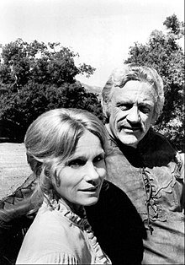
Eva Marie Saint and James Arness as Kate and Zeb Macahan
There the family learns that the first battle of the war is likely to occur at Bull Run, near Zeb and Tim's parents' home. Tim returns to Virginia while the family winters in the Indian Territories. Zeb learns that a friend has been murdered by Dutton /…/

