A The American Revolution

Watch these videos. Think critically while watching.

The American Revolution - OverSimplified (Part 1)
The American Revolution - OverSimplified (Part 2)

B Persuasive Writing: The Declaration of Independence (1776)
Which persuasive techniques can you find The Declaration of Independence?
1 Read the article “3 Lessons in Persuasion the Declaration of Independence Can Teach Today's Leaders”: https://www.inc.com/carmine-gallo/the-declaration-of-independence-was-written-to-go-viral-here-are-3-tips-entrepreneurs-can-learn-from-jeffersons-pen.html
2 Watch “What you might not know about The Declaration of Independence”: https://youtu.be/LKJMWHCUoiw
3 Take a look at The Declaration of Independence: https://www.archives.gov/founding-docs/declaration
4 Watch the congress approve The Declaration of Independence (from John Adams, miniseries 2008): https://youtu.be/nrvpZxMfKaU
5 Watch A Declaration of Revolution: https://youtu.be/VIpACJRnZZE
6 Listen to the beginning and end of The Declaration of Independence: https://youtu.be/ib1tXAnlPuY
7 Now (and/or next lesson) analyze The Declaration of Independence. Which persuasive techniques did Thomas Jefferson use when he wrote The Declaration of Independence? (Alliteration? Facts? Opinion? Rhetorical Questions? Emotion? Statistics and numbers? The rule of three? Ethos? Pathos? Logos?) Give some examples.
The Declaration of Independence: https://www.archives.gov/founding-docs/declaration-transcript
Alliteration: life, liberty; death, desolation
Facts:
Opinion:
Rhetorical Questions:
Emotion:
Statistics and numbers:
The rule of three:
Ethos:
Pathos:
Logos:

If there is time left:
Read this text from ReadWorks.org
The Declaration of Independence is one of the most important documents in the history of the United States. It was an official act taken by all 13 American colonies in declaring independence from British rule.

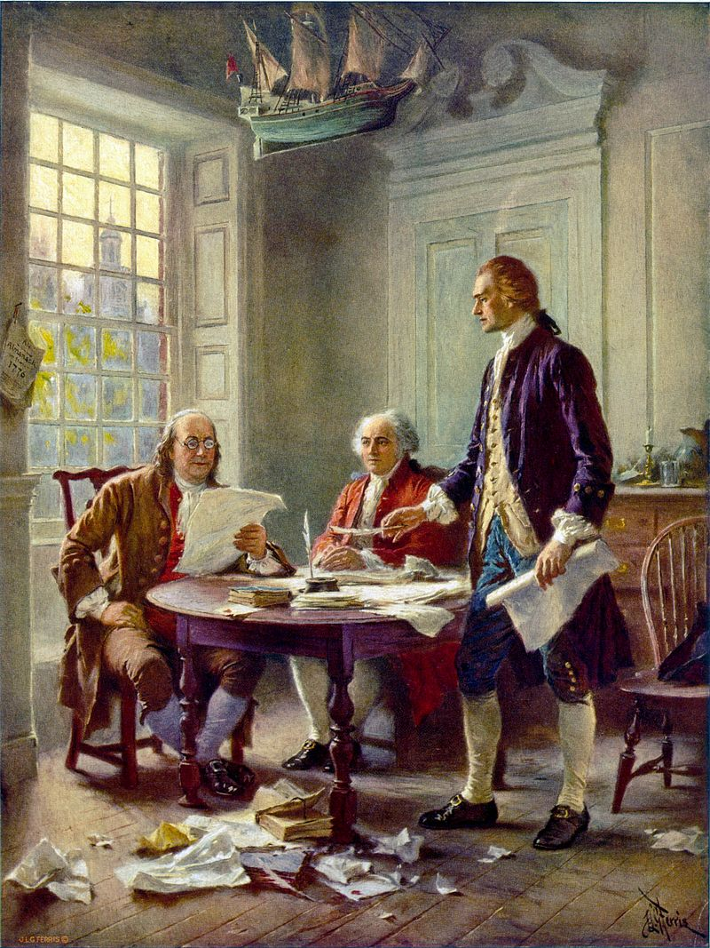
This idealized depiction of (left to right) Franklin, Adams, and Jefferson working on the Declaration was widely reprinted (by Jean Leon Gerome Ferris, 1900)

People in the colonies were unhappy that they did not have a say in their government and still had to pay taxes. The Stamp Act of 1765 collected taxes on paper goods like legal documents, newspapers, and playing cards. In one act of protest, men dumped the cargo of a ship full of British tea into Boston Harbor in 1773; this is now called the Boston Tea Party. In 1775, the colonists went to war with Great Britain.
The war between the colonies and Great Britain was called the American Revolutionary War (1775-1783). A group of men came together in the summer of 1776 to find ways to become independent from Great Britain. The committee included John Adams, Benjamin Franklin, Thomas Jefferson, Robert R. Livingston, and Roger Sherman.
The Declaration of Independence was originally written by Thomas Jefferson. Benjamin Franklin, John Adams, and Jefferson then worked together to make changes to the document. The final draft of the Declaration of Independence was adopted on July 4, 1776, but the actual signing of the final document was on August 2, 1776.
Writing and signing the Declaration of Independence took courage, but it was an important step in the founding of our Government. A famous phrase from the Declaration is “We hold these truths to be self-evident, that all men are created equal, that they are endowed by their Creator with certain unalienable Rights, that among those are Life, Liberty, and the pursuit of Happiness.”
Declaration of Independence facts and figures:
• John Hancock was the first to sign. His signature was so large and bold that people use ‘John Hancock’ to mean a signature.
• The Declaration of Independence is on public display in the Rotunda of the National Archives in Washington, DC.

If there is time:
C Grammar | EF CLASS

Sign in to https://class.ef.com/

Part 1 EF CLASS ASSIGNMENT Introducing myself: Simple present 'to be'
Do the assignment. Remember to submit all your answers.

Part 2 EF CLASS ASSIGNMENT Shopping for food: 'Some' and 'any'
Do the assignment. Remember to submit all your answers.

Part 3 EF CLASS ASSIGNMENT Strange traditions: Passives
Do the assignment. Remember to submit all your answers.

Part 4 EF CLASS ASSIGNMENT Infinitives of purpose
Do the assignment. Remember to submit all your answers.

Part 5 EF CLASS ASSIGNMENT Future life: Future with 'will' Songs that have special meaning: A presentation
Do the assignment. Remember to submit all your answers.

Part 6 EF CLASS ASSIGNMENT Songs that have special meaning: A presentation
Do the assignment. Remember to submit all your answers.

