Part 1: STORYTELLING Story Circle / The Hero’s Journey

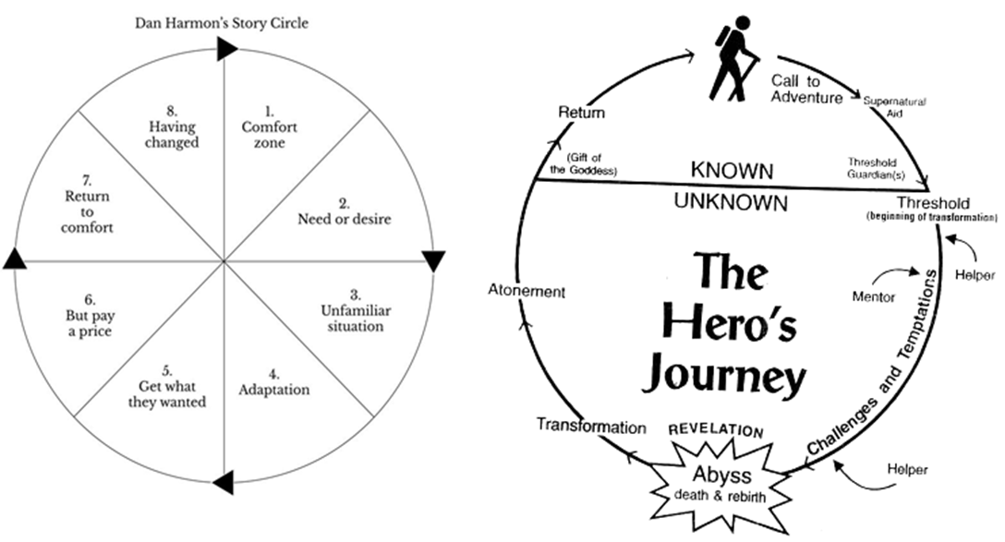
(Illustrations from https://www.story24.film/story-circle.php)

Part 2: STORYTELLING How to Write a Good Story

Difficult word/phrase | Swedish translation | Easier replacement
creative |  | showing the ability to create interesting new things
abandon |  | leave behind and alone permanently
storytelling |  | acts of telling stories (or lies)
principles |  | ways of thinking/basic truths/rules
transformation |  | change in form or appearance
narrative |  | story
storyteller |  | person who tells stories (or lies)
seemingly |  | appearing to be
protagonist |  | main character
atonement |  | reparation for a wrong or injury
normal |  | usual/ commonly and regular/ healthy
chaos |  | noise and confusion
realm |  | world
seeks |  | looks (for)
capture |  | take (prisoner) by force
a host of |  | many
abyss |  | an immeasurably depth
crime wave |  | sudden rise in crime
antagonist |  | person or thing that irritates and fights with someone or something
avenge |  | get revenge
journey |  | trip

Watch this video: https://youtu.be/-XGUVkOmPTA
And/or watch the first 9 minutes of this video: https://youtu.be/tFaUmXIobuE

Part 3: KNOWLEDGE ASSESSMENT

Now go to your school email account and answer the questions LESSON 8 KNOWLEDGE ASSESSMENT

If there is time left:

Look at the story circle / hero’s journey illustrations, and start creating your own short story.

