Style and Grammar: Parts of Speech
1. Listen to the teacher. Participate in the discussions. Ask and/or answer questions.

Eight Parts of Speech:

Nouns
Pronouns
Verbs
Adjectives
Adverbs
Prepositions
Conjunctions
Interjections

Parts of Speech Rap

Parts of Speech in English | Learn English Grammar

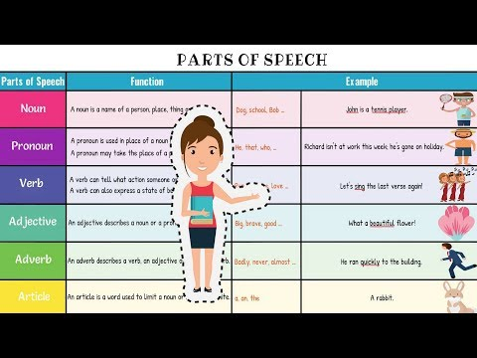

2. Choose the answer option that identifies the underlined word or words in the sentence.

  - He will visit his grandparents for two weeks this summer.
  - adverb
  - conjunction
  - noun
  - pronoun

  - Silently read your book.
  - adjective
  - adverb
  - preposition
  - verb

  - Hey! Put that down!
  - adjective
  - adverb
  - interjection
  - noun

  - Liam brought his notebook to class.
  - adverb
  - conjunction
  - noun
  - pronoun

  - Your test scores were almost perfect.
  - adjective
  - adverb
  - noun
  - pronoun

  - Please join us for the birthday party this afternoon.
  - conjunction
  - interjection
  - pronoun
  - verb

  - French onion soup is on the lunch menu.
  - adjective
  - adverb
  - conjunction
  - noun

  - The coach jumped for joy.
  - adjective
  - conjunction
  - preposition
  - verb

  - Classes will resume in the fall.
  - noun
  - preposition
  - pronoun
  - verb

  - I understand the directions.
  - interjection
  - noun
  - preposition
  - verb

  - Fathers and sons enjoy taking long fishing trips to the lake.
  - adverb
  - conjunction
  - noun
  - preposition

  - The postman will deliver it to your house.
  - conjunction
  - interjection
  - pronoun
  - verb

  - She wore a beautiful dress to the party.
  - adjective
  - adverb
  - interjection
  - noun

  - Wow! That was scary.
  - interjection
  - noun
  - preposition
  - verb

  - The music concert was loud and entertaining.
  - adjective
  - adverb
  - noun
  - pronoun

