The American Civil War Part 2

☐ Part 1: Vocabulary
Difficult word/phrase | Translation | Easier replacement
seceded |  | broke off from (a country)
abolition |  | permanent ending
thoroughly |  | completely
cited |  | referred to
hostility |  | hatred
proclaimed |  | announced
normal |  | (usual/ commonly and regular/ healthy)
rupture |  | break
cornerstone |  | (very important thing/big stone laid at the corner of a building)
prominent |  | well-known/obvious
abolitionist |  | (person who tried to end slavery)
formerly |  | before now
revisionist history |  | (lying about history)

☐ Part 2: A lie embedded in American history
Watch the video A lie embedded in American history: https://youtu.be/XP0_wnaW-a0

☐ Part 3: Quiz
Answer the questions: https://ed.ted.com/on/KwhAQygq

☐ Part 4: How the West Was Won
Watch 15 minutes of How the West Was Won: https://youtu.be/gpTmgKAzKWU

Zeb Macahan is a well-known mountain man and scout working for the U.S. Army in the Indian Territories. The pilot movie shows Zeb not having seen his family for ten years and with the Civil War approaching, deciding to visit them in Manassas, Virginia. As war comes too close to home, Zeb's sister-in-law, Kate, convinces her husband, Zeb's brother Tim, to move their two sons, Seth and Jed (renamed Luke and Josh in the remaining episodes) and two daughters (Jessie and Laura) out west.
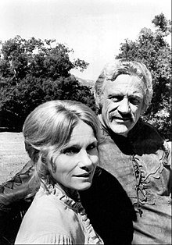
Eva Marie Saint and James Arness as Kate and Zeb Macahan
There the family learns that the first battle of the war is likely to occur at Bull Run, near Zeb and Tim's parents' home. Tim returns to Virginia while the family winters in the Indian Territories. Zeb learns that a friend has been murdered by Dutton /…/

