The American Civil War Part 5

☐ Part 1: Vocabulary
Difficult words with definitions:
Difficult word/phrase | Translation | Easier replacement
mention |  | talk about/say
civil war |  | (war between groups that all live in one country)
compromise |  | agreement (where everyone meets in the middle)
tenacious |  | stubborn
advocate of |  | supporter of
expansion |  | (act of something getting bigger, wider, etc.)
promoted |  | (helped increase/showed in a good way)
constructing |  | building
transcontinental |  | (going completely across a country)
railroad |  | (set of steel tracks for trains)
terminus |  | last point/end
territories |  | (land areas owned or controlled by someone)
required |  | needed/demanded
sovereignty |  | independent power (of a country)

☐ Part 2: How one piece of legislation divided a nation
Watch the video How one piece of legislation divided a nation (6 min): hhttps://youtu.be/oWww0YIf-JE

☐ Part 3: Quiz
Answer the questions: https://ed.ted.com/on/sbV0Zfc0

☐ Part 4: How the West Was Won
Watch 15 minutes of How the West Was Won: https://youtu.be/gpTmgKAzKWU

Zeb Macahan is a well-known mountain man and scout working for the U.S. Army in the Indian Territories. The pilot movie shows Zeb not having seen his family for ten years and with the Civil War approaching, deciding to visit them in Manassas, Virginia. As war comes too close to home, Zeb's sister-in-law, Kate, convinces her husband, Zeb's brother Tim, to move their two sons, Seth and Jed (renamed Luke and Josh in the remaining episodes) and two daughters (Jessie and Laura) out west.
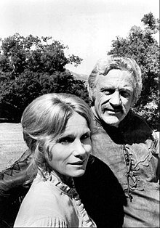
Eva Marie Saint and James Arness as Kate and Zeb Macahan
There the family learns that the first battle of the war is likely to occur at Bull Run, near Zeb and Tim's parents' home. Tim returns to Virginia while the family winters in the Indian Territories. Zeb learns that a friend has been murdered by Dutton /…/

