The American Civil War

☐ Part 1: Vocabulary
Difficult words with definitions:
Difficult word/phrase | Translation | Easier replacement
civil war | inbördeskrig | (war between groups that all live in one country)
contentious | omtvistad | argument-causing
underlying | underliggande | hidden (under)
decades | årtionden | at least 20 years
incredible | otrolig | amazing
amid | mitt i | in the middle of
expansion | expansion | (act of something getting bigger, wider, etc.)
emerged | framkom | came out/became visible
fundamental | grundläggande | basic
plantation | plantage | large farm with crops
agriculture | lantbruk | farming
territories | områden | land areas owned or controlled by someone
abolitionist | abolitionist | person who tried to end slavery
essential | grundläggande | extremely important
voters | väljare | people (who vote)

☐ Part 2: The American Civil War
Watch the video The Civil War Explained in 10 Minutes: https://youtu.be/Wegf4KsNgBo

☐ Part 3: Discussion
Turn to the person(s) next to you and discuss these topics:

- Does war ever do any good?
- Who benefits from war? How?
- Do you think there would be fewer wars if all countries were ruled by women?
- What are some of the damages and consequences of a war?
- What can we do to stop wars?
Questions from https://lingoties.com/en/conversation-questions/topic/war

☐ Part 4: How the West Was Won

Zeb Macahan is a well-known mountain man and scout working for the U.S. Army in the Indian Territories. The pilot movie shows Zeb not having seen his family for ten years and with the Civil War approaching, deciding to visit them in Manassas, Virginia. As war comes too close to home, Zeb's sister-in-law, Kate, convinces her husband, Zeb's brother Tim, to move their two sons, Seth and Jed (renamed Luke and Josh in the remaining episodes) and two daughters (Jessie and Laura) out west.
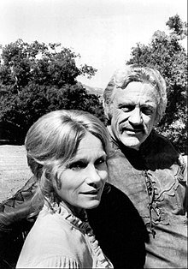
Eva Marie Saint and James Arness as Kate and Zeb Macahan
There the family learns that the first battle of the war is likely to occur at Bull Run, near Zeb and Tim's parents' home. Tim returns to Virginia while the family winters in the Indian Territories. Zeb learns that a friend has been murdered by Dutton /…/

Watch the first 15 minutes of How the West Was Won: https://youtu.be/gpTmgKAzKWU

